**ONLINE JOB PORTAL**

by

Teyash Basu (2147259)

Under the guidance of

# Dr. Gobi R

A Project report submitted in partial fulfilment of the requirements for the award of the degree of Master of Computer Applications of CHRIST (Deemed to be University)

March - 2022

CERTIFICATE

*This is to certify that the report titled* ***JOBPORTAL*** *is a bona fide record of work done by* ***Teyash Basu (2147259)*** *of CHRIST (Deemed to be University), Bengaluru, in partial fulfillment of the requirements of III Trimester MCA during the year 2022.0*

## Head of the Department Project Guide

Valued-by:

|  |  |  |
| --- | --- | --- |
|  | Name | : Teyash Basu |
| 1. | Register Number | : 2147259 |
|  | Examination Centre | : CHRIST (Deemed to be University) |
| 2. | Date of Exam | : |

# ACKNOWLEDGEMENTS

I would like to extend our sincere thanks to the Department of Computer Science for

providing us with the excellent opportunity to work on this project. I would like to thank our

guide, Prof. Gobi R for helping us with this project with their valuable insights.

I also thank all the teachers who have taught us so far for arming us with the knowledge that

helped us complete this project. I would also want to thank our friends who helped us in

finishing this project within a limited time frame.

I express my sincere thanks to all faculty members and staff of the **Department of Computer Science**, CHRIST (Deemed to be University), for their valuable suggestions during the course of this project. Their critical suggestions helped us to improve the project work. .

I would like to express my sincere thanks to all my friends, colleagues, parents and all those who have directly or indirectly assisted during this work.

# ABSTRACT

The project is titled ‘Job Portal**’** is aimed to create Job portal service was developed for creating an interactive job vacancy form for candidates. This web application manages updates both from the job seekers as well as the companies. It’s unique development methodology helps in acquiring the client and candidate information and separating them according to the job requirements and vacancies. The online access to it provides details of the job. An employer being registered in the web site has the facility to use the services.

Being an authorized user he can publish vacancy details and can search no of Employees on portal and also he can search candidates on basis of the key skill which employee provides on registration. Candidates can search for jobs on the basis of their skills. According to the search job are fetched from different websites.

# TABLE OF CONTENTS

|  |  |
| --- | --- |
| **Certificates** | ii |
| **Acknowledgements** | iv |
| **Abstract** | v |
| **Table of Contents** | vii |
| **List of Tables** | x |
| **List of Figures** | xi |
| **Abbreviations** | xii |
| 1. Introduction    1. Project Description    2. Existing System    3. Objectives       1. Objectives of System       2. Objectives of Social Dash       3. Project Scope       4. Proposed System | 1  1  1  1  1  1  2  2 |
| 1. System Analysis    1. Requirement Specifications       1. Functional Requirements       2. Non Functional Requirements    2. System Requirements       1. Hardware Requirements       2. Software Requirements | 4  5  5  5  6  7  7 |
| 1. System Design    1. System Architecture    2. Module Design       1. User Login Module       2. Dashboard Module | 13  13  14  14  14 |

|  |  |
| --- | --- |
| * + 1. Analytics Chart Module     2. Enquiry Module     3. Messages Module     4. Task Progress Module     5. Notification Module     6. Profile Module   1. Database Design      1. Table Structure      2. Data Flow Diagram      3. Entity Relationship Diagram | 15  15  15  15  15  15  16  16  17  20 |
| 1. Implementation    1. Coding Standards    2. Screenshots       1. Dashboard       2. Profile       3. Notifications       4. Task Manager       5. Messages       6. Percentage Meters       7. Analytics Chart       8. Overall Analytics       9. Graph of Facebook Vs Instagram Vs LinkedIn       10. Tasks Panel       11. Enquiry Form | 23  23  26  26  26  27  27  28  28  29  29  30  30  31 |
| 1. Testing    1. Test Cases       1. Application initiation       2. Launching Dashboard       3. Closing Application       4. Minimizing and Maximizing Application    2. Test Reports | 32  32  32  33  33  33  34 |

|  |  |
| --- | --- |
| 1. Conclusion    1. Limitations and Future Enhancements | 35  35 |
| References | 36 |

**LIST OF TABLES**

|  |  |  |
| --- | --- | --- |
| **Table. No.** | **Table Name** | **Page No.** |
| Table 3.1 | User Table | 16 |
| Table 3.2 | Execution Table | 16 |
| Table 5.1 | Application Initiation | 32 |
| Table 5.2 | Launching Dashboard | 33 |
| Table 5.3 | Closing Application | 33 |
| Table 5.4 | Minimizing and Maximizing Application | 33 |

# LIST OF FIGURES

|  |  |  |
| --- | --- | --- |
| **Fig. No.** | **Figure Name** | **Page No.** |
| Fig 3.1 | System Architecture diagram | 14 |
| Fig 3.2 | Level - 0, Data Flow Diagram | 18 |
| Fig 3.3 | Level - 1, Data Flow Diagram | 19 |
| Fig 3.4 | Level - 2, Data Flow Diagram | 20 |
| Fig 3.5 | ER Diagram | 22 |
| Fig 4.1 | Dashboard | 26 |
| Fig 4.2 | User Profile | 26 |
| Fig 4.3 | Notification | 27 |
| Fig 4.4 | Task Manager | 27 |
| Fig 4.5 | Messages | 28 |
| Fig 4.6 | Percentage Meters | 28 |
| Fig 4.7 | Analytics Chart | 29 |
| Fig 4.8 | Overall Analytics | 29 |
| Fig 4.9 | Graph of Facebook Vs Instagram Vs LinkedIn | 30 |
| Fig 4.10 | Tasks Panel | 30 |
| Fig 4.11 | Enquiry Panel | 31 |

**ABBREVIATIONS**

HTML - Hypertext Marked up Language CSS - Cascading style sheet

JS - Java Script

XML - Extensible Markup Language OS - Operating System

RAM - Random Access Memory JSON - JavaScript Object Notation PDF - Portable Document Format DFD - Data flow diagram

ER - Entity Relationship UI - User Interface

WWW - World Wide Web

# INTRODUCTION

Now a day, we know that searching of jobs is so difficult in proficient areas the portal developed for the providing the simple and good job searching. With the help of this portal easily the job seeker can submit their resume and get the lot of opportunity of the job related to their profile. And by this website the companies or employer can also find the good and well profiled resume.

## Objectives

The online job Portal System that is to be developed provides the members with jobs information, online applying for jobs and many other facilities. This system provides service to the job applicants to search for working opportunities. Job Portal will allow job provider to establish one to one relationships with candidates. This Portal will primarily focus on the posting and management of job vacancies. This system is designed such that ultimately all vacancies will be posted online and would offer employers the facilities to post their vacancies online. It helps to review and manage the resulting applications efficiently through the web. Employer can also find the resume according to key skill in very less amount of time.

## Scope

As of Indian market, there is ample opportunities for the job portal sites, as more and more number of educated and skilled young people are coming out each and every year. Also, as the growth rate of India is zooming to be at a healthy rate over 7%, so it is boom time for corporate also. So, more and more number of lucrative careers will be available for the job seekers. So, it is now the right period for the job portal sites to think out of the box, and to make most of the opportunities available.

## Requirement Specification

### Requirement Description

1. Registration Employee or Employer can register with valid details like contact details, experience details, profile details.

2.Search Employee Can Search job according to their interest. And also apply for that job. Employer search candidates for their requirements using keyword. Employer also can communicate with employee for their any other query or information via send message.

3. Job Post Employer post job for their organization. And include job vacancy, salary details, working hours, designation details, experienced details.

4. Manage Account Employee can also delete his/her account anytime. Admin Can Manage Employee and Employer Details. Admin observed Users Action like job posting, candidate details false or not.

5. Employee search jobs on the basis of skills. Suitable jobs appear from different job portals.

### Detailed Module Description with all Functionalities

1. Registration In the registration module job seeker have to include all the details like personal details, contact details, education details like school , graduation, post-graduation, course certification details etc. Also job seeker has to add his experience details, job requirements and uploading resume and photo. While job recruiter has to add his contact details and organization details for the registration and upload company logo and profile.

2. Job Post Employer can post a job by providing all the job details like qualifications details, requirements for the job, designation details, job salary details and also provide type of jobs. They also can delete the jobs whenever they want. After successfully posted a job it will be available for all the job seekers who are searching for a job. And it will be available on home page as recently posted job.

3. Search Employee Can Search job according to their interest. And also apply for that job or they can add into wishlist for future whenever they find for job for that company then they easily find out company from wishlist. Employer search candidates for their requirements using keyword like technology. And also can communicate with employee for their any other query or information via send message .and also employer see the resume of applicants.

4. Manage Account While employers can manage their job postings. And providing all the job details like qualifications details, requirements for the job, designation details, job salary

details and also provide type of jobs. They also can delete the jobs whenever they want. While employee can manage their wishlist, applied for job and also getting full details of employer. Employees can delete their account anytime. Also they can apply for the different jobs according to their interests.

# SYSTEM DESIGN

The system designs the developers to design and plan the development of the application. The application since wraps different technologies to form better experience it needs complex planning and design plans. Integration of the application seems to be easy but is a complex task. The application integrates are written in a wide variety of languages and coding standards. The Social Dash who develop the application create the code for their easy use and processing. However, the others who have less experience and ideas on the code and working face a huge challenge in running these codes.

The system design depicts the system architecture, various modules, the database design and the system configuration. The information on these facilitates the development of the solution for the Social Dash. The complex social media platform analysis can be made easy for social dash so that they can do the processing faster and efficiently.

### 2.1 Used Case Diagram

### 

Fig.2.1

## Class Diagram

## 

Fig.2.2

## Detailed Design

## 2.3.1 Entity Relationship Diagram

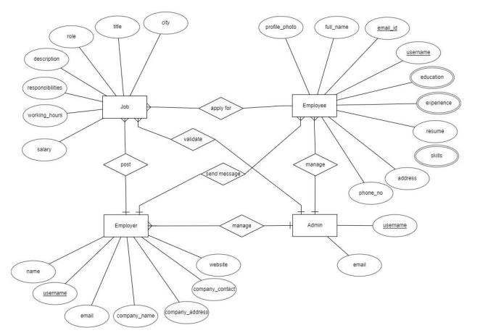

Fig.2.3

## 2.3.2 Relationship Schema

## 

Fig 2.4

**2.3.3 Hardware requirement**

The expected hardware requirements for the effective performance of the application have the following considerations and specifications.

* **Processor**: Intel Core i3 and above
* **Hard Disk**: 128GB and above
* **RAM**: 4GB of RAM and above

### Software requirements

The expected software requirements for the effective performance of the application have the following considerations and specifications.

* **OS**: Ubuntu 20 LTS (64 bit) , Windows 8 and above
* **Frontend Tools**: JavaScript, HTML, Bootstrap, jQuery, CSS, JSON, Spring Boots, RestAPI
* **Backend Tools**: Java, GitHub
* **IDE**: Eclipse
* **Database Tools**: MySQL, PostgreSQL, MySQL Workbench

### Ubuntu 20.04

Ubuntu 20.04 LTS, is based on the long-term supported Linux release series 5.4. HWE stack updated to Linux release series 5.8. Support for new hardware including Intel Comet Lake CPUs and initial Tiger Lake platforms, AMD Navi 12 and 14 GPUs, Arcturus and Renoir APUs along with Navi 12 + Arcturus power features. Support has been added for the exFAT filesystem, virtio-fs for sharing filesystems with virtualized guests and fs-verity for detecting file modifications. Built-in support for the WireGuard VPN and Enablement of lockdown in integrity mode. Ubuntu Desktop flavor now always tracks HWE kernel. It means that from January 2021 the Ubuntu Desktop will gain new major kernel versions every 6 months through to the summer of 2022, even if you installed Ubuntu Desktop earlier than this. It is a powerful operating system for building analysis systems.

### JavaScript (JS)

JS, is a lightweight, interpreted, or just-in-time compiled programming language with first-class functions. While it is most well-known as the scripting language for Web pages, many non-browser environments also use it, such as Node.js, JS is a lightweight, interpreted, object-oriented language with first-class functions, and is known as the scripting language for Web pages, but it's used in many non-browser environments as well. It is a prototype-based, multi-paradigm scripting language that is dynamic, and supports object-oriented, imperative, and functional programming styles. JS runs on the client-side of the web, which can be used to design/program how the web pages behave on the occurrence of an event. JS is easy to learn and also a powerful scripting language, widely used for controlling web page behavior.

### Hypertext Markup Language (HTML)

HTML, is the standard markup language for documents designed to be displayed in a web browser. It can be assisted by technologies such as CSS and scripting languages such as JS. Web browsers receive HTML documents from a web server or local storage and render the documents into multimedia web pages. HTML describes the structure of a web page semantically and originally included cues for the appearance of the document. HTML elements are the building blocks of HTML pages. With HTML constructs, images and other objects such as interactive forms may be embedded into the rendered page. HTML provides a means to create structured documents by denoting structural semantics for text such as headings, paragraphs, lists, links, quotes and other items.

### Bootstrap

Bootstrap, is a free and open-source CSS framework directed at responsive, mobile- first front-end web development. It contains CSS and JS based design templates for typography, forms, buttons, navigation, and other interface components. Bootstrap is an HTML, CSS & JS Library that focuses on simplifying the development of informative web pages. The primary purpose of adding it to a web project is to apply Bootstrap's choices of color, size, font and layout to that project. As such, the primary factor is whether the developers in charge find those choices to their liking. Once added to a project, Bootstrap provides basic style definitions for all HTML elements. The

result is a uniform appearance for prose, tables and form elements across web browsers. Besides, developers can take advantage of CSS classes defined in Bootstrap to further customize the appearance of their contents.

### JQuery

JQuery, is a fast, small, and feature-rich JS library. It makes things like HTML document traversal and manipulation, event handling, animation, and Ajax much simpler with an easy-to-use API that works across a multitude of browsers. With a combination of versatility and extensibility, jQuery has changed the way that millions of people write JS. JQuery’s syntax is designed to make it easier to navigate a document, select DOM elements, create animations, handle events, and develop Ajax applications. JQuery also provides capabilities for developers to create plug-ins on top of the JS library. This enables developers to create abstractions for low-level interaction and animation, advanced effects and high-level, theme able widgets. The modular approach to the jQuery library allows the creation of powerful dynamic web pages and Web applications.

### Cascading Style Sheets (CSS)

CSS, is a style sheet language used for describing the presentation of a document written in a markup language such as HTML. CSS is a cornerstone technology of the WWW, alongside HTML and JS. CSS is designed to enable the separation of presentation and content, including layout, colours, and fonts. This separation can improve content accessibility, provide more flexibility and control in the specification of presentation characteristics, enable multiple web pages to share formatting by specifying the relevant CSS in a separate .css file which reduces complexity and repetition in the structural content as well as enabling the .css file to be cached to improve the page load speed between the pages that share the file and its formatting. Separation of formatting and content also makes it possible to present the same markup page in different styles for different rendering methods. CSS also has rules for alternate formatting if the content is accessed on a mobile device.

### JSON

JSON (JavaScript Object Notation) is a lightweight data-interchange format. It is easy for humans to read and write. It is easy for machines to parse and generate. It is based

on a subset of the JavaScript Programming Language Standard ECMA-262 3rd Edition

- December 1999. JSON is a text format that is completely language independent but uses conventions that are familiar to programmers of the C-family of languages, including C, C++, C#, Java, JavaScript, Perl, Python, and many others. These properties make JSON an ideal data-interchange language

### Spring Boots

Spring Boot is an open-source Java-based framework used to create a micro Service. Spring Boot provides a good platform for Java developers to develop a stand-alone and production-grade spring application that you can just run. It provides a flexible way to configure Java Beans, XML configurations, and Database Transactions. It provides powerful batch processing and manages REST endpoints. In Spring Boot, everything is auto-configured; no manual configurations are needed. It offers annotation-based spring applications. It eases dependency management and includes Embedded Servlet Container.

### Rest API

A RESTful API is an architectural style for an application program interface ([API](https://searchapparchitecture.techtarget.com/definition/application-program-interface-API)) that uses HTTP requests to access and use data. That data can be used to GET, PUT, POST and DELETE data types, which refers to the reading, updating, creating and deleting of operations concerning resources. An API for a website is [code](https://whatis.techtarget.com/definition/code) that allows two software programs to communicate with each other. The API spells out the proper way for a developer to write a program requesting services from an operating system or other application.

A RESTful API also referred to as a RESTful web service or REST API is based on representational state transfer ([REST](https://searchapparchitecture.techtarget.com/definition/REST-REpresentational-State-Transfer)), which is an architectural style and approach to communications often used in [web services](https://searchapparchitecture.techtarget.com/definition/Web-services) development.

REST technology is generally preferred over other similar technologies. This tends to be the case because REST uses less [bandwidth,](https://searchnetworking.techtarget.com/definition/bandwidth) making it more suitable for efficient internet usage. RESTful APIs can also be built with programming languages such as JavaScript or Python.

### Java

JAVA was developed by Sun Microsystems Inc in 1991, later acquired by Oracle Corporation. It was developed by James Gosling and Patrick Naught on. It is a simple programming language. Writing, compiling, and debugging a program is easy in java. It helps to create modular programs and reusable code. Some of the exclusive features of this language are JDK, JVM, bytecode, and JRE.

### GitHub

GitHub, Inc., is a provider of Internet hosting for software development and version control using Git. It offers the distributed version control and source code management functionality of Git, plus its features. GitHub is a code hosting platform for version control and collaboration. It lets you and others work together on projects from anywhere. This tutorial teaches you GitHub essentials like repositories, branches, commits, and Pull Requests. You’ll create your own Hello World repository and learn GitHub’s Pull Request workflow, a popular way to create and review code.

### Eclipse

The Eclipse platform which provides the foundation for the Eclipse IDE is composed of plug-ins and is designed to be extensible using additional plug-ins. Developed using Java, the Eclipse platform can be used to develop rich client applications, integrated development environments, and other tools. Eclipse can be used as an IDE for any programming language for which a plug-in is available. The Java Development Tools (JDT) project provides a plug-in that allows Eclipse to be used as a Java IDE.

### MySQL

MySQL is a relational database management system based on SQL – Structured Query Language. The application is used for a wide range of purposes, including data warehousing, e-commerce, and logging applications. The most common use for MySQL however, is for the purpose of a web database. It can be used to store anything from a single record of information to an entire inventory of available products for an online store. In association with a scripting language such as PHP or Perl (both offered on our hosting accounts), it is possible to create websites that will interact in real-time

with a MySQL database to rapidly display categorized and searchable information to a website user.

### PostgreSQL

PostgreSQL is a powerful, open source object-relational database system. It has more than 15 years of active development phase and a proven architecture that has earned it a strong reputation for reliability, data integrity, and correctness. PostgreSQL (pronounced as **post-gress-Q-L**) is an open source relational database management system (DBMS) developed by a worldwide team of volunteers. PostgreSQL is not controlled by any corporation or other private entity and the source code is available free of charge. PostgreSQL, originally called Postgres, was created at UCB by a computer science professor named Michael Stonebraker. Stonebraker started Postgres in 1986 as a follow-up project to its predecessor, Ingres, now owned by Computer Associates.

### SQL Work Bench

MySQL Workbench is a unified visual tool for database architects, developers, and DBAs. MySQL Workbench provides data modeling, SQL development, and comprehensive administration tools for server configuration, user administration, backup, and much more. MySQL Workbench is available on Windows, Linux and Mac OS X. MySQL Workbench enable a DBA, developer, or data architect to visually design, model, generate, and manage databases. It includes everything a data modeler needs for creating complex ER models, forward and reverse engineering, and also delivers key features for performing difficult change management and documentation tasks that normally require much time and effort

## Registration

In the registration module job seeker have to include all the details like personal details, contact details, education details like school , graduation, post-graduation, course certification details etc. Also job seeker has to add his experience details, job requirements and uploading resume and photo. While job recruiter has to add his contact details and organization details for the registration and upload company logo and profile..

### Job Post

Employer can post a job by providing all the job details like qualifications details, requirements for the job, designation details, job salary details and also provide type of jobs. They also can delete the jobs whenever they want. After successfully posted a job it will be available for all the job seekers who are searching for a job. And it will be available on home page as recently posted.

### Search

Employee Can Search job according to their interest. And also apply for that job or they can add into wishlist for future whenever they find for job for that company then they easily find out company from wishlist. Employer search candidates for their requirements using keyword like technology. And also can communicate with employee for their any other query or information via send message .and also employer see the resume of applicants.

### Manage Account

While employers can manage their job postings. And providing all the job details like qualifications details, requirements for the job, designation details, job salary details and also provide type of jobs. They also can delete the jobs whenever they want. While employee can manage their wishlist, applied for job and also getting full details of employer. Employees can delete their account anytime. Also they can apply for the different jobs according to their interests.

## Database Design

The database design shows the important parameters for keeping the data safe and sound. The important part of any application is the data that the application generates, there should be a proper format where the data is stored and processed. Processing the tools and keeping the track of the data in the application is in a table format. The table structure associated with the application is shown below, apart from the table structure, the data flow diagram shows the flows of data in the application, which helps to design the application in a more structured form. The ER Diagram or the Entity-Relationship diagram shows how the different entities in the application are connected.

### Table Structure

The table structure covers the data base structure of the application, the various tables that are associated with the application are covered here, the tables include the user table, the tools table, the pipeline table, the execution table. These tables help in organizing the data in the application. More details of the tables are described below.

Table 3.1 User Table

|  |  |  |  |  |  |
| --- | --- | --- | --- | --- | --- |
| ID | Username | Name | Email | Phone | Address |
| Integer | String | String | String | String | String |

Table 3.1 shows the user table and the fields associated with the table. The user table stores the details of the user in the application. This helps to keep track of the user information in the application, who all are dealing with the application to run their analysis. These details can be used to fill in the inputs required for some of the tools and can also be used in the report module for the generation of reports.

Table 3.2 Execution Table

|  |  |  |  |  |  |  |
| --- | --- | --- | --- | --- | --- | --- |
| ID | Product ID | User ID | Time Stamp | End time | Status | Configuration |
| Integer | Integer | Integer | Date time | Date time | Boolean | JSON |

Table 3.2 covers the execution history table that is used to track the execution information of the application. This table also constitutes to the execution history of the dashboard as this table is used to keep track of the various execution instances in the

application. The execution table helps to keep track of the executions made in the application. This also keeps track of the product id and the user id of the person who commented or liked or shared the particular product or advertisement. The timestamp and end time stories are the start and end time of a particular social media contacts.

### Data Flow Diagram (DFD)

Data flow diagram helps in understanding the flow of data of a system or a process is represented by DFD. It also gives insight into the inputs and outputs of each entity and the process itself. DFD does not have a control flow and no loops or decision rules are present. Specific operations depending on the type of data can be explained by a flowchart. Data Flow Diagrams can be represented in several ways. The DFD belongs to structured-analysis modelling tools. Data Flow diagrams are very popular because they help us to visualize the major steps and data involved in software-system processes.

# 3. IMPLEMENTATION

The application is implemented on the top of Spring Boot framework. The main language behind the application is JavaScript which in turn work in tandem with the Java and much more languages written codes. The main benefit of this approach is that the users can be presented with a good appealing user interface where the people can access the application and process their data.

The User interface design is created with HTML, CSS and Bootstrap which gives a very appealing visual layout of the elements that a user might interact within a website or technological product.

## Screenshots



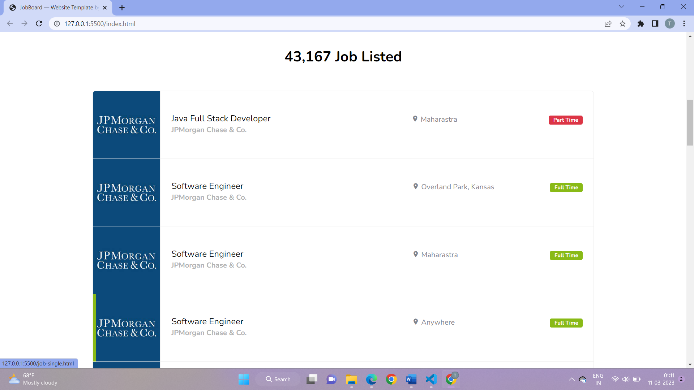

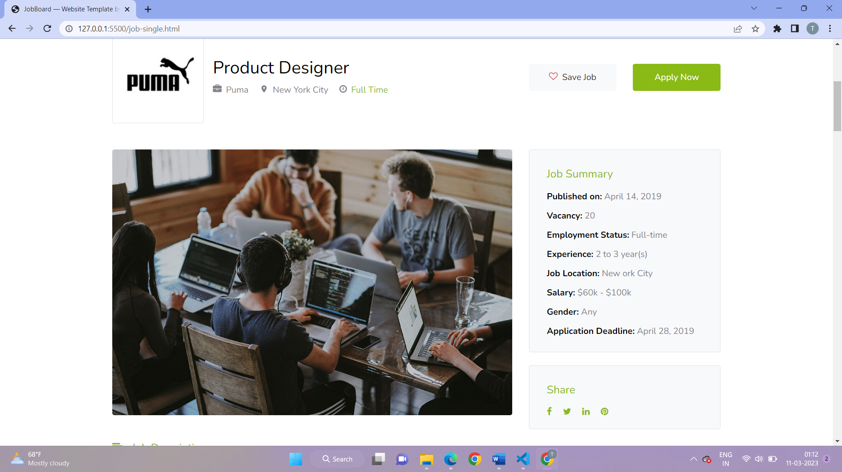

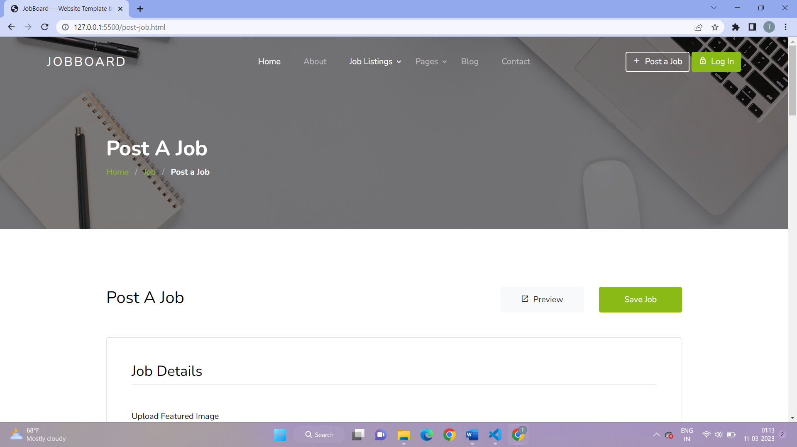

# TESTING

Testing is the process of evaluating a system or its component(s) with the intent to find whether it satisfies the specified requirements or not. Testing is executing a system to identify any gaps, errors or missing requirements contrary to the actual desire or requirements. Testing is a process that is done to verify that the application is working as intended and the development process is completed and the product is ready for deployment. There are different types of testing here we test the application based on the different scenarios where the application is expected to be working.

## Test Cases

A test case is a document, which has a set of test data, preconditions, expected results and post conditions, developed for a particular test scenario to verify compliance against a specific requirement. Test Case acts as the starting point for the test execution, and after applying a set of input values, the application has a definitive outcome and leaves the system at some endpoint or also known as execution post condition. The test cases here have the following fields, which include the test case ID / serial number, the test case scenario, test case description, test steps, expected outcome, observed outcome and result.

### Data Directory

### 

### 

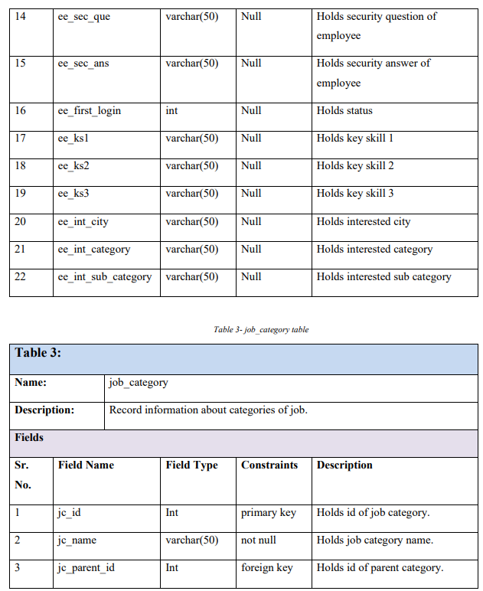

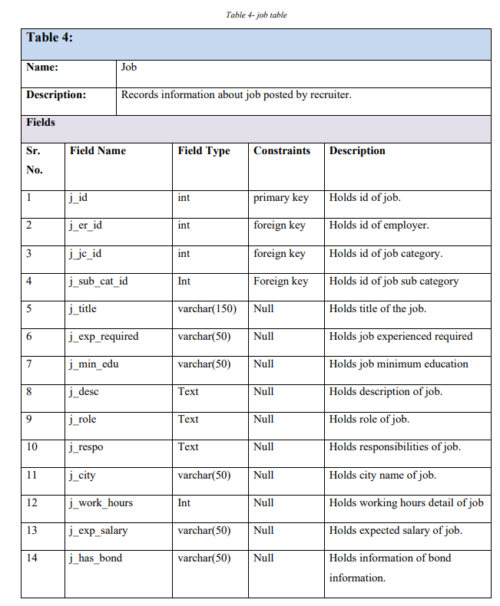

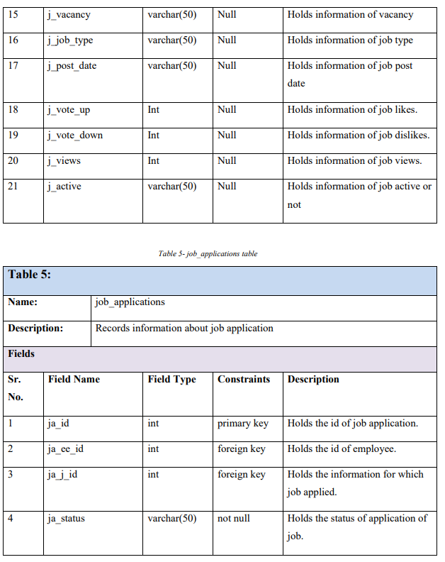

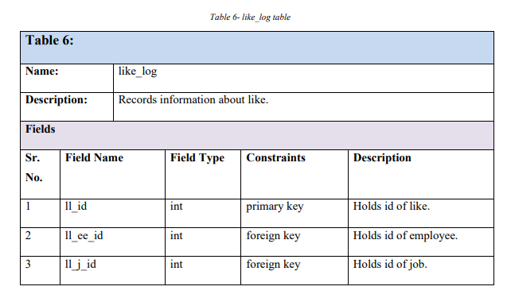

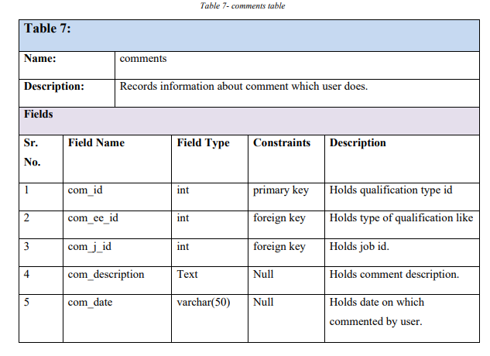

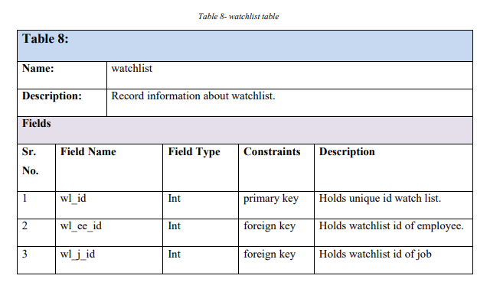

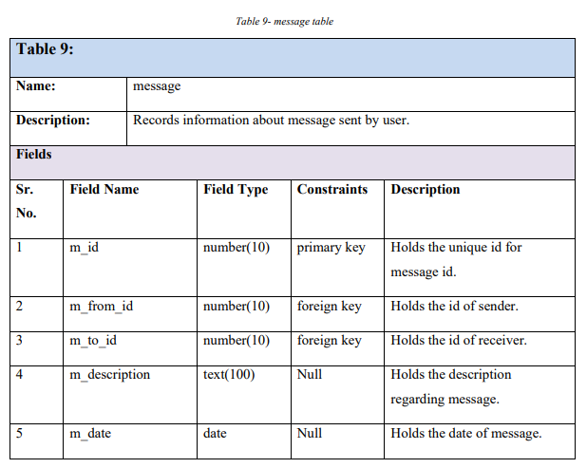

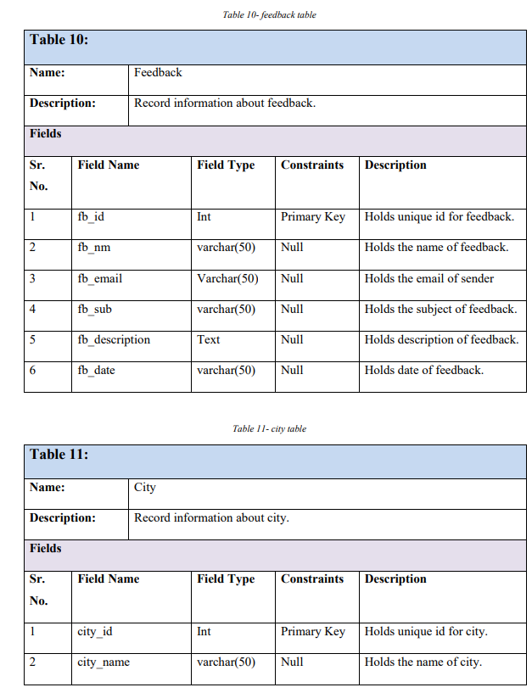

* + 1. **Test Cases and Results**

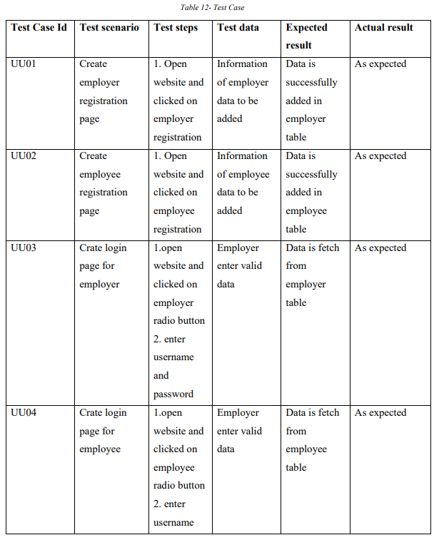

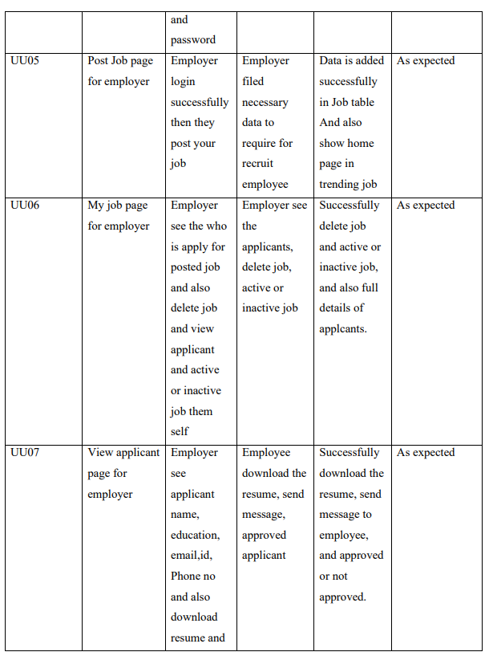

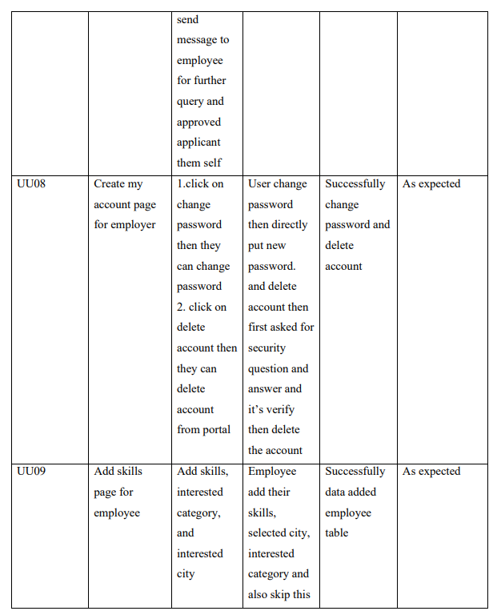

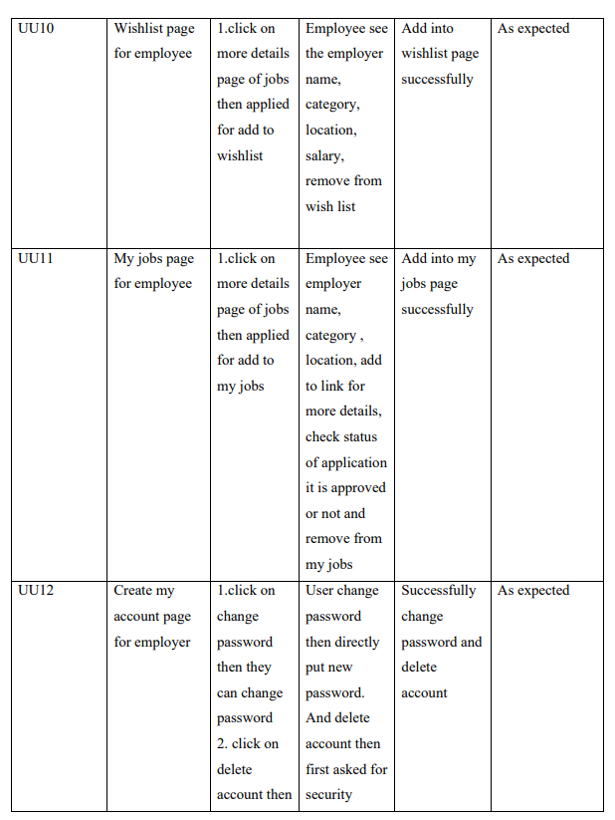

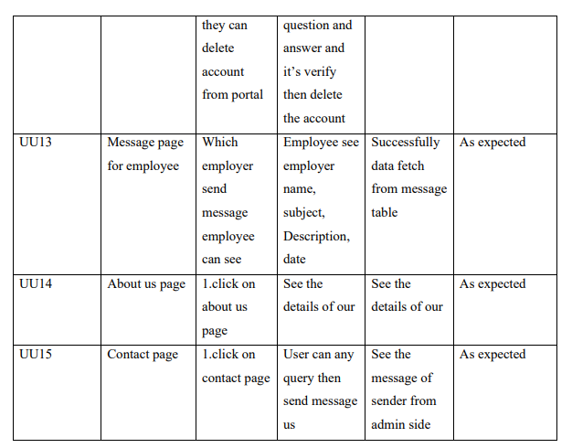

# 6. CONCLUSION

It has been a great pleasure for me to work on this exciting and challenging project. This project proved good for me as it provided practical knowledge of not only programming in ASP.NET web based application and no some extent Windows Application and SQL Server, but also about all handling procedure related with online job portal. It also provides knowledge about the latest technology used in developing web enabled application and client server technology that will be great demand in future. This will provide better opportunities and guidance in future in developing projects independently.

# REFERENCES

[1]. Arruda, W. (2013, August 27). Three elements of an effective social media strategy Forbes

[2]. Ravindran, T., Yeow Kuan, A., & Hoe Lian, D. (2014). Antecedents and effects of social network fatigue.Journal of the Association for Information & Technology, 65 (11), 2306-2320. doi:10.1002/asi.23122 Roberts, B. (2012). Social media gets strategic. (cover story). HR Magazine, 57(10), 30-38

[3]. Mayfield, T., III. (2011, January). A commander’s strategy for social media. Joint Force Quarterly, 1 (60), 79-83.

[4]. Ubuntu Wiki Contributors, “Focal Fossa / Release Notes - Ubuntu Wiki”, February 11, 2021, Focal Fossa / Release Notes - Ubuntu Wiki, March 21, 2021, https://wiki.ubuntu.com/FocalFossa/ReleaseNotes#Official_flavor_release_notes

[5]. Mozilla Developer Network Contributors, “JavaScript, Mozilla Developer Network Web Docs”, February 21, 2021, JavaScript, Mozilla Developer Network Web Docs, March 21, 2021, https://developer.mozilla.org/en-

US/docs/Web/JavaScript

[6]. Wikimedia Foundation Contributors, “HTML”, Wikimedia Foundation, February 28, 2021, Wikipedia, March 21, 2021, <https://en.wikipedia.org/wiki/HTML>

[7]. Association Management Center. (n.d.). Best practices in social media: A resource guide for associations